NLP Spam Classification

Install nltk
conda install -c anaconda nltk

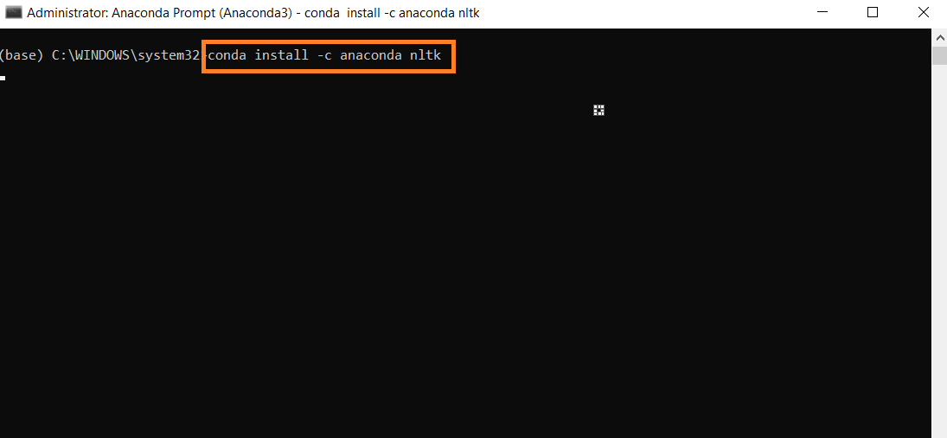

Data Set: Email_Spam_Classification.txt

Import Libraries

import pandas as pd
from sklearn.feature_extraction.text import CountVectorizer
import numpy as np
import os

Check the Current Working Directory
print (os.getcwd())

Change the Current Working Directory

os.chdir ('C:\\Noble\\Training\\Course Content\\NLP\\Training\\Data Set\\')
print (os.getcwd())

Read the Data
df = pd.read_csv("Email_Spam_Classification.txt")
display (df)

Display Shape
print (df.shape)

Display Value Count
print (df['spam'].value_counts())

Display first record

display (df['text'][0])

Bag of Word

vector = CountVectorizer()
vec = vector.fit_transform(df.text)
bow= vec.toarray()
print (bow.shape)
display (bow)
Create the Model

from sklearn.naive_bayes import MultinomialNB
classifier = MultinomialNB()
label = df.spam
classifier.fit(vec, label)

Prediction

pred = classifier.predict (vec)
print (pred.shape)
print (pred)

Accuracy score

from sklearn.metrics import accuracy_score
print (accuracy_score (label,pred))

Classification Report

from sklearn.metrics import classification_report
print(classification_report(label,pred,zero_division=0))

Confusion Matrix

from sklearn.metrics import confusion_matrix
cm = confusion_matrix (label,pred)
print (cm)

Display Report

df_pred = pd.DataFrame (pred,columns = ['Spam Prediction'])
result = pd.concat ([df,df_pred ],axis = 1)
result.to_csv('C:\\Noble\\Training\\DS Temporary Files\\Spam_Prediction.csv')
display (result)

Future Prediction

dummy = ["You won a car!!", "Free goodies, hurry up....dont miss the offer", "How are you, Good night!", "great discounts, just pay shipping!!"]

dummy_vec = vector.transform(dummy)
display (dummy_vec.shape)
display (dummy_vec.toarray())

Display Result

display (classifier.predict(dummy_vec))

